Christopher Guay

Garden Glory Chapter 1

IST 210

2/3/2020

A)

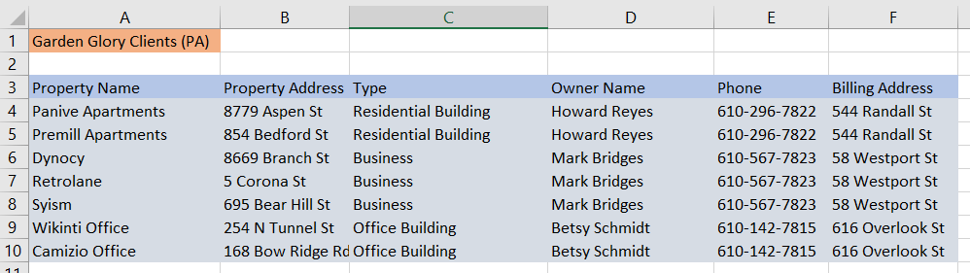

B)

One modification problem is that if a property changes owner, the phone number and billing address doesn’t change with the owner change, which falsifies records. Another problem is that if an owner’s billing address changes, it doesn’t carry through to the other cells, which causes confusion as to the real billing address of the owner. The same problem exists for changing the owner’s phone number.

C)   
The revised List:

Table A:

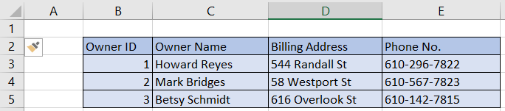

Table B:

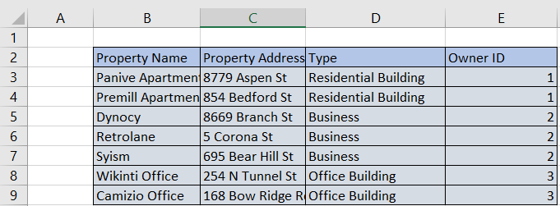 Continued on next page…

All parameters and details on the owners of a property (shown in table A) were “factored out” of the original table, which became Table B. The linking parameter between these two tables is the Owner ID. In Table A, a user can change details that would stem from a change of ownership, billing address, and phone number without causing issues with continuity and ambiguity of parameters within the tables.